How to Create a Navigation Bar using Fireworks

Ensure you have created a home button first by using the How to Create a Button in Fireworks help guide.

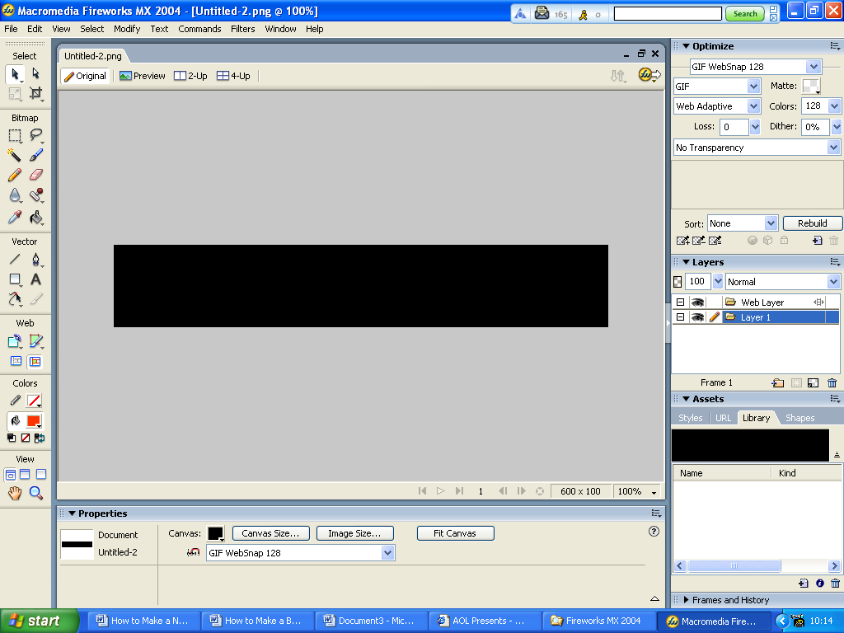
1. Create a new canvas by 620 x 100 choosing a black background
- Select >import symbols icon from the library panel

- Select > import symbols and choose the button you require – double click
- Select >import
- Drag five instances (buttons) onto your navigation bar – use the arrow keys on the keyboard to nudge the buttons into place.
- Select the 1st button to the left of the Navigation bar > select the properties box
a) Text: > enter text > Home b) Link: > enter text > index.htm c) Alt: > enter text > Displays the Home Page
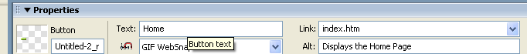
Example

- Select the 2nd button to the left of the Navigation bar > select the properties box
a) Text: > enter text > Events b) Links: events.htm c) Alt: > enter text > Displays Events

- Select the middle button
a) Text: > enter text > Rides b) Links: rides.htm c) Alt: > enter text > Displays Splasshh Rides

- Select 2nd button to the right
a) Text: > enter text > Shop b) Links: shop.htm c) Alt: > enter text > Displays Gift Shops
- Select button at the far right of the Navigation bar
a) Text: > enter text > Contact b) Links: contact.htm c) Alt: > enter text > Displays Contact Numbers

- Save the navigation bar as a .png file.

